Grant Application
Do you need up to £500 to support your project?
This form helps the Ayre Offshore Wind Farm Community Fund understand more about
your proposed project and determine whether it is eligible for funding.
The fund criteria and the project appraisal and approval process are explained in the Fund
Guidance. Please ensure that you read the guidance before filling in this form.
It will save time if you provide all relevant details and documents requested, otherwise
there could be delays in processing your application.
If you have any queries on the application form, please email a.tait@qair.energy
Applications will be acknowledged within two weeks of receipt and decisions will be notified
within six weeks. Successful applications will be published on our website.
Section One: Organisation Details
1: Full name and type of organisation:
2: Contact name and role in organisation:
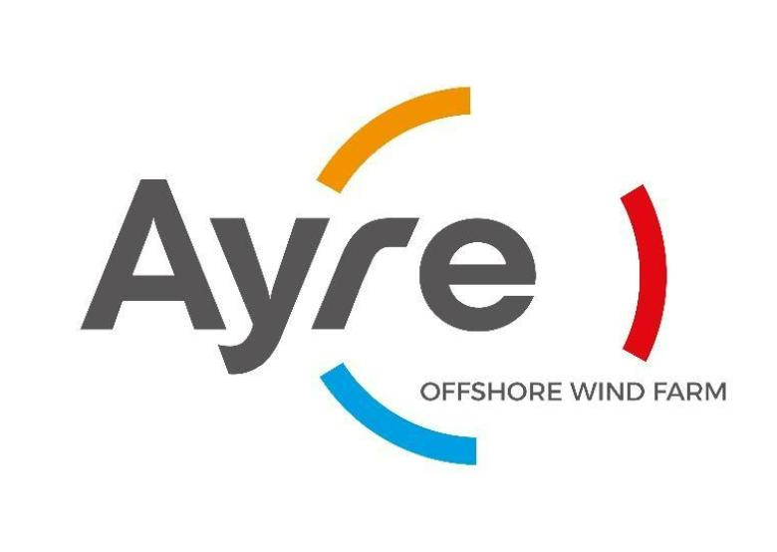

3: What are the main activities of your organisation/what service do you provide?
4: If applicable, what’s your organisation charity number or registered company number?
5: Telephone number
6: Email
7
: Address where we can write to you. (Your own address or the address of the organisation
you represent) including postcode
Section Two: Grant Application
1: What is the name of your project?
2: Where will the project be delivered?


3
: Briefly describe the project you would like funding for and who will benefit from it.
How have you identified the need for this project in your community.
Does your project require permits or planning permission? If so are those in place and please
provide evidence.
How will you deliver this activity / use equipment.
4: How will you measure the success of this project?
Section Three: Costs
1: How much money do you require and what will you spend it on? Please provide a breakdown of
costs
2: We require quotations if your grant request is for equipment, vehicles or refurbishment work.
Please supply two competitive quotes and any evidence of having sought more than two.
3. What other sources of funding have you applied for?
Funder
Funding Requested
Date outcome
expected
Outcome


If your grant is successful, please specify who the award should be made payable to. This
must not be an individual’s bank account and must be an account where two signatories
are required.
4. Account name
By submitting this application form to the Ayre Offshore WindFarm Community Fund I
certify that the information contained in this application is correct, and that I, the contact
person listed in Section 1, are authorised to make the application on behalf of the above
group. You understand that decisions made by the Ayre Offshore WindFarm Community
Fund are final.
Signed:
Data protection
We will use the information you give us to help assess your application and administer any grant we
award you. We may also use it to analyse our grant-making and for our own research. We may share
information with other organisations providing matched funding.
Completed forms and accompanying information should be returned
electronically to a.tait@qair.energy

